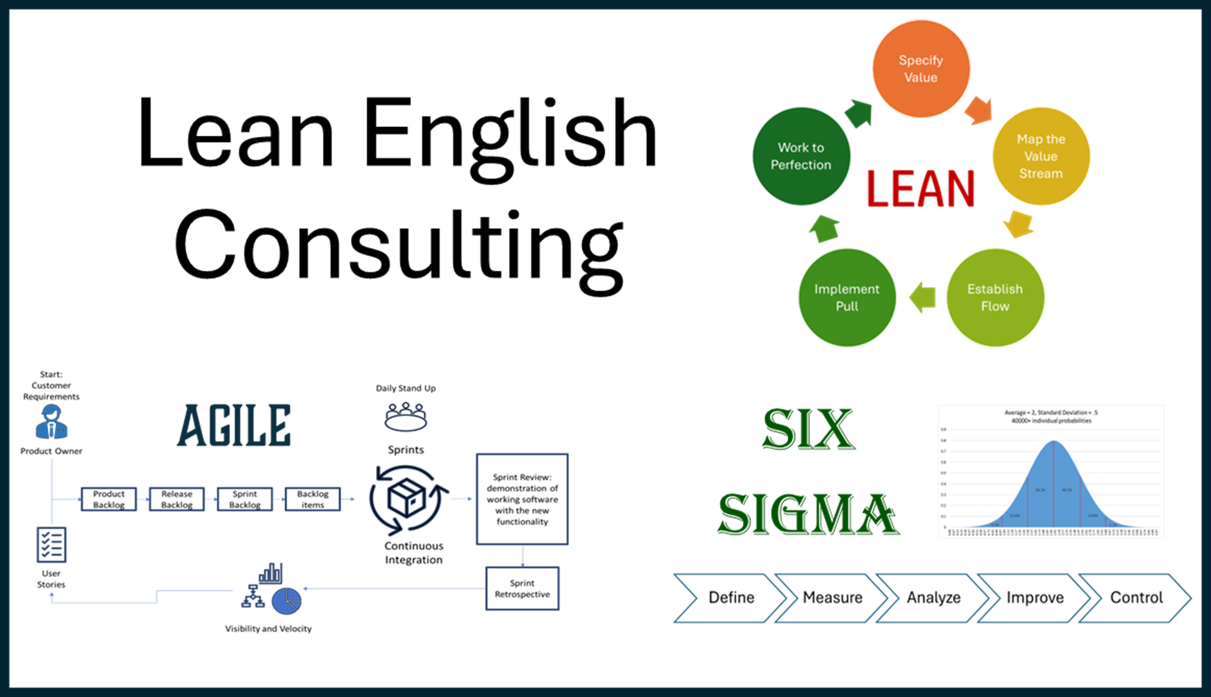  Lean English Consulting; helping individuals and businesses learn the English language through business training courses.  Lean English Consulting’s mission is to offer multiple value streams to our students who are looking to improve their English language proficiency as well as their career. We do this by tailoring in-person language training around subjects that interest our clients.  Our objectives  - Improve our clients’ English proficiency in four measurable areas: oral comprehension, oral production, written comprehension and written production.  - Increase our clients’ understanding of Continuous Process Improvement methodologies such as Lean, Six Sigma and Agile.  - Offer a cost-effect alternative for language learning for individuals and small-to-medium sized businesses.  - Provide unique experiences in language learning with hands-on mentorship courses for business teams.
  Who We Are
  About Us
  Established in 2024, Lean English Consulting was founded on the premise that English language training can do more than just help you ask for directions. In our modern society, there is not enough time to do all the things we need to do. Our specialty is to add significant value to your training budget by offering individuals and teams training in Lean, Six Sigma and Agile.
  Contact Us
  Phone: +33 07 49 62 53 99
  Email: info@leanenglishconsulting.com
  Web: Leanenglishconsulting.com
  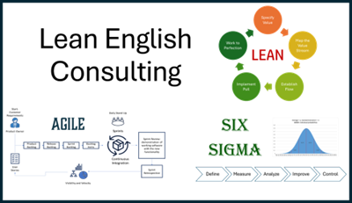 |  | Lean English Consulting (LEC)  12 Route du Conquet  29280 Plouzané
  
  Lean English Consulting (LEC)
    - Take your English, and your business, to the next level.
,
  Service Implementation  Getting started with LEC  Learning English can be confusing, so we try to implement our services in a methodical way. To get started, contact LEC at your convenience.  After initial contact, LEC starts by identifying our clients’ proficiency and subject matter interest. Then we tailor the coursework to be a challenge, but not a chore.  After a plan is created, we share it with our clients and gain final approval before scheduling our courses. Clients can choose from online or onsite workplace courses for individuals and business teams.  Feedback sessions take place during the course to ensure high levels of customer satisfaction. |  |  | We deliver training online or onsite  Individuals can receive training online, from the comfort of their home, or if there are 4 or more colleagues at a business who wish to train on the same day, we will come to you.  “Root cause analysis can be directly applied to machine & computer engineering, and Systems Thinking finds a wide field of application in my domain.” Bernard CESCHIA, Project Manager, Thales  Unsure of which methodology is right for your business?  LEC offers executive level courses to help companies determine which training methodology works best for their industry. Call us today to schedule a presentation.  For our disabled clients  The "Disability Law" of February 11, 2005, obligates training organizations to adapt training methods to the needs related to disabilities by implementing specific support, an adapted training duration, and adapted delivery methods. At LEC, we structure our training as much as possible to meet these needs. We strive to: 1. Listen to every request from people with disabilities without discrimination. 2. Take their specific needs into account when we create a training plan. 3. Provide services that allow the disabled to meet us on their terms, online or at their workplace. 4. Inform all staff of LEC’s commitment to working with the disabled. |  |  |   Reading in a new language is the goal of many of our clients.  Our Services  Lean English Consulting focuses on our clients’ need for targeted English language training. After an assessment of proficiency and a needs analysis, we tailor our training and create a plan to help our clients reach their objectives.  Along with grammar, pronunciation and comprehension, we offer training in Continuous Process Improvement methodologies for individuals and clients who are interested in Lean, Six Sigma and Agile.  We provide individual sessions online and team training at your location for busy companies who would like groups to receive business training in English. Team training can be booked by the day or week, and includes classroom and hands-on mentoring project work.  The best way to decide if LEC is right for you is to give us a call today and schedule your free Needs Analysis.

